Understanding Growth Patterns of Pickleweed (*Salicornia pacifica*) Across Elkhorn Slough NERR Reserve

Github repository hyperlink-https://github.com/Smillersfsu/Biol708/tree/main/Code (check Code folder for Data Visualization Project)

Savannah K. Miller

October 27, 2024

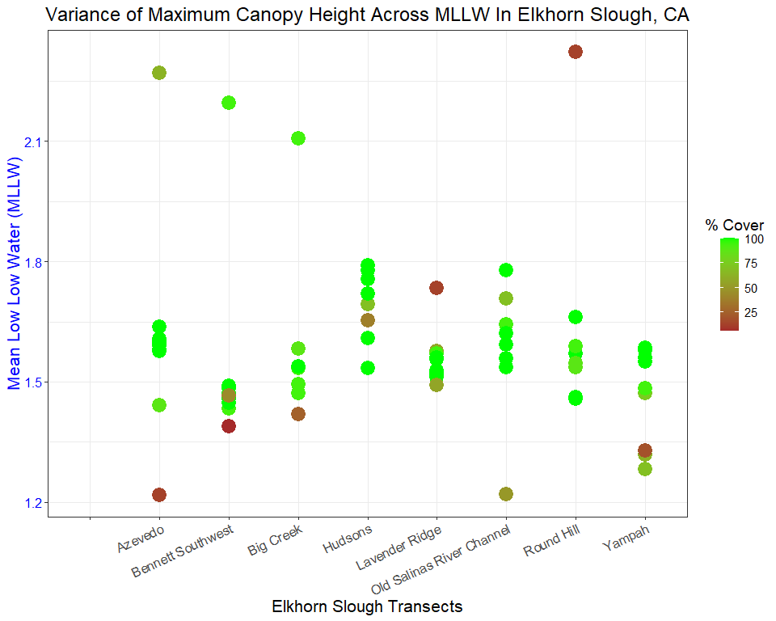

Figure 1. Cover of Pickleweed across Quadrat Measurements throughout transects of Elkhorn Slough, in relation to MLLW of each measurement. Data indicates that the highest rates of cover near 100% have a cut-off at position of 1.8 around MLLW

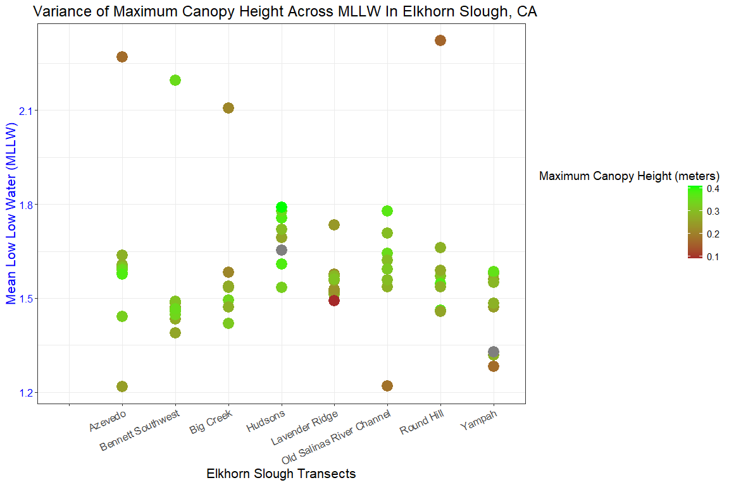

Figure 2. Maximum Canopy Height of Pickleweed across Quadrat Measurements throughout transects of Elkhorn Slough, in relation to MLLW of each measurement. Data mirrors the % Cover data, with the highest canopies existing at 1.8 or below MLLW